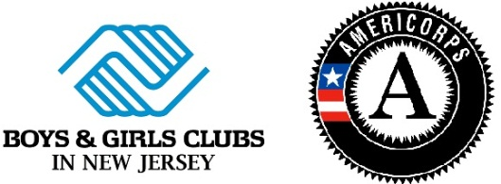
-AmeriCorps Member Travel Reimbursement Request Form-
To receive reimbursement, you must submit this form and a copy of your travel receipt(s), where needed, within one (1) month of the expense date. Reimbursement may be given between your current club site and the location of travel.
I, _______________________________, serving at the Boys & Girls Club in __________________
Print Member’s Name
am requesting travel reimbursement for the following day ______/______/______.
Date of Travel
Please explain your reason for travel:
________________________________________________________________________________
________________________________________________________________________________

Please check one:

I traveled by way of public transportation and my receipts are included.

I used my personal vehicle.
Miles from Club site to location | Miles from location to Club site | Total Trip Miles

Submit travel reimbursement form and receipts, where needed, by mail, fax or scan to:
OR Fax: (973) 773-3103 OR Scan: scardoso@bgcnj.org

BGCNJ
Attn: Susan Cardoso
822 Clifton Ave
Clifton, NJ 07013

Do not forget to send proof of receipts! If you use EZ Pass, submit your monthly billing statement.

Please do not write in this section. This section is to be completed by BGCNJ.
Reimbursement form and attached receipt reviewed by Program Manager on ___________________.
Approved Declined
_____Susan Cardoso_____________ _________________________________
AmeriCorps Program Manager Signature

