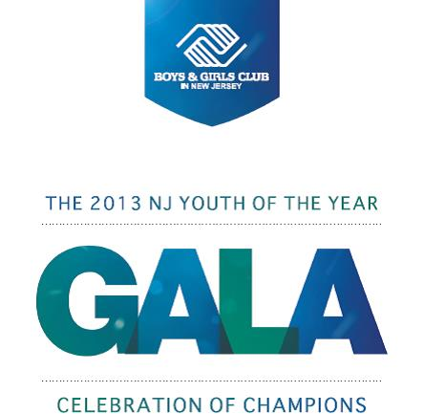

Silent Auction

Auction Item | Donor | Estimated Value
- Four Box tickets to 2013 N.Y. Jets Game. Includes Food & Drink and a autographed N.Y. Jet item. | Jon Sobel | $4,000
- Niemen Marcus Cosmetology Party. Spend an afternoon at Garden State Plaza’s location being pampered with up to 12 friends. | Niemen Marcus | $400
- 4 Course Dinner for 30 guests at The Élan. This beautiful banquet hall is recently renovated and located in Lodi on Rt. 46W. | The Élan | $3,500
- 2 Giant Stadium Seats autographed by Phil Simms and more! Seats that experienced Pope John Paul II’s visit, Countless Bruce Springteen & the E Street Band Concerts and of course NY Jet & Giants Games! | New York Giants | $500
- 2 suite tickets to July 1st Bruno Mars Concert at Prudential Center. Includes a $75 dollar gift certificate to the nearby Dinosaur BBQ | PSEG  Dinosaur BBQ | $500
- 2 Round trip tickets on United Airlines to anywhere in US48, Mexico, Alaska or the Carribean. | United Airlines | $1,400
- 6 tickets to the Camden Aquarium | PSEG | $150
- FantaSea Resorts Timeshare in Atlantic City

- Jeep Compass Hybrid Men’s 22” Satin Grey bicycle | Kent International
- Jeep Compass Hybrid Women’s 17” Sky Blue bicycle | Kent International
- Magic Johnson autographed basketball
- Italian Gift Basket with $400 Shop Rite gift cards | ShopRite | $500

For item information, bid pricing and other updates
as they become available please call Shane Sudol @
973-478-7662 x14.

